VISVESVARAYA TECHNOLOGICAL UNIVERSITY

“JnanaSangama”, Belgaum -590014, Karnataka.



LAB REPORT

on

Analysis and Design of Algorithms

Submitted by

PRAJWAL BHAT (1BM20CS107)

in partial fulfilment for the award of the degree of

# BACHELOR OF ENGINEERING

in

COMPUTER SCIENCE AND ENGINEERING



B.M.S. COLLEGE OF ENGINEERING

(Autonomous Institution under VTU)

BENGALURU-560019

May-2022 to July-2022

B. M. S. College of Engineering,

Bull Temple Road, Bangalore 560019

(Affiliated To Visvesvaraya Technological University, Belgaum)

Department of Computer Science and Engineering



CERTIFICATE

This is to certify that the Lab work entitled “Analysis and Design of Algorithms” carried out by PRAJWAL BHAT (1BM20CS107), who is Bonafede student of B. M. S. College of Engineering. It is in partial fulfilment for the award of Bachelor of Engineering in Computer Science and Engineering of the Visvesvaraya Technological University, Belgaum during the year 2022. The Lab report has been approved as it satisfies the academic requirements in respect of an Analysis and Design of Algorithms - (19CS4PCADA) work prescribed for the said degree.

Name of the Lab-In charge: Rekha G.S. Dr. Jyothi S Nayak

Assistant Professor Professor and Head

Department of CSE Department of CSE

BMSCE, Bengaluru BMSCE, Bengaluru

Index Sheet

|  |  |
| --- | --- |
| Sl.  No. | Experiment Title |
| 1 | Write a recursive program to Solve  a) Towers-of-Hanoi problem b) To find GCD |
| 2 | Implement Recursive Binary search and Linear search and determine the time required to search an element. Repeat the experiment for different values of N and plot a graph of the time taken versus N. |
| 3 | Sort a given set of N integer elements using Selection Sort technique and compute its time taken. Run the program for different values of N and record the time taken to sort. |
| 4 | Write program to do the following:   * Print all the nodes reachable from a given starting node in a digraph using BFS method. * Check whether a given graph is connected or not using DFS method. |
| 5 | Sort a given set of N integer elements using Insertion Sort technique and compute its time taken. |
| 6 | Write program to obtain the Topological ordering of vertices in a given digraph. |
| 7 | Implement Johnson Trotter algorithm to generate permutations. |
| 8 | Sort a given set of N integer elements using Merge Sort technique and compute its time taken. Run the program for different values of N and record the time taken to sort. |
| 9 | Sort a given set of N integer elements using Quick Sort technique and compute its time taken. |
| 10 | Sort a given set of N integer elements using Heap Sort technique and compute its time taken. |
| 11 | Implement Warshall’s algorithm using dynamic programming |
| 12 | Implement 0/1 Knapsack problem using dynamic programming. |
| 13 | Implement All Pair Shortest paths problem using Floyd’s algorithm. |
| 14 | Find Minimum Cost Spanning Tree of a given undirected graph using Prim’s algorithm. |
| 15 | Find Minimum Cost Spanning Tree of a given undirected graph using Kruskals algorithm. |
| 16 | From a given vertex in a weighted connected graph, find shortest paths to other vertices using Dijkstra’s algorithm. |
| 17 | Implement “Sum of Subsets” using Backtracking. “Sum of Subsets” problem:  Find a subset of a given set S = {s1,s2,……,sn} of n positive integers whose sum is equal to a given positive integer d. For example, if S = {1,2,5,6,8} and d = 9 there are two solutions {1,2,6} and {1,8}. A suitable message is to be displayed if the given problem instance doesn’t have a solution. |
| 18 | Implement “N-Queens Problem” using Backtracking. |

Course Outcome

|  |  |
| --- | --- |
| CO1 | Ability to analyse time complexity of Recursive and Non-Recursive algorithms using asymptotic notations. |
| CO2 | Ability to design efficient algorithms using various design techniques. |
| CO3 | Ability to apply the knowledge of complexity classes P, NP, and NP-Complete and prove certain problems are NP-Complete |
| CO4 | Ability to conduct practical experiments to solve problems using an appropriate designing method and find time efficiency. |

# Experiment 1

Write a recursive program to solve

A: Towers-of-Hanoi problem

Program:

#include<stdio.h> void TOH(int,char,char,char); void main()

{ int n;

printf("Number of discs: "); scanf("%d",&n);

TOH(n,'A','B','C');

}

void TOH(int n,char x,char y,char z)

{ if(n>0)

{

TOH(n-1,x,z,y); printf("\n%c -> %c",x,y);

TOH(n-1,z,y,x);

}

}

Output:

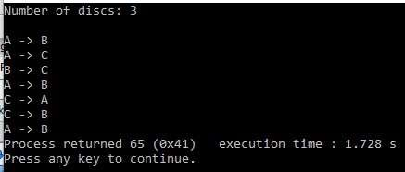

## B: To find GCD

Program: #include<stdio.h> int main() { double HCF; int n1,n2;

printf("Enter numbers to fing gcd: "); scanf("%d %d", &n1,&n2); HCF=hcf(n1,n2); printf("GCD=%.3f", HCF);

}

hcf(int m,int n)

{ if(n==0) return m; else

return(hcf(n,m%n));

}

Output:



# Experiment 2

Implement Recursive Binary search and Linear search and determine the time required to search an element. Repeat the experiment for different values of N and plot a graph of the time taken versus N.

Binary Search:

Program:

#include<stdio.h>

#include<stdlib.h>

#include<time.h>

void delay()

{

int i,j,temp; for(i=0;i<500000;i++) temp=30/333; return;

}

int binary(int l,int h,int arr[],int key)

{ int m; delay(); m=(l+h)/2; if(l>h) return -1; if(arr[m]==key) return (m+1); else if(key>arr[m]) return (binary(m+1,h,arr,key)); else

return (binary(l,m-1,arr,key));

}

int main()

{

clock_t start,end; int m,l,h,flag; int n, arr[10000],key,i; printf("Enter the value of n: "); scanf("%d",&n); for(i=0;i<n;i++) arr[i]=i;

key=arr[n-1]; l=0; h=n-1; i=0; start=clock(); flag=binary(l,h,arr,key); if(flag==-1)

printf("\nKey not found!"); else

printf("\nKey found at %d position",flag); end=clock();

printf("\nTime taken: %f",(double)(end-start)/CLOCKS_PER_SEC);

}

Output:

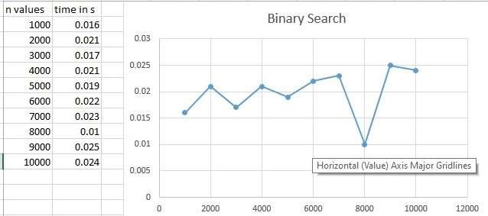

Linear Search:

Program:

#include<stdio.h>

#include<stdlib.h>

#include<time.h>

void delay()

{

int i,j,temp; for(i=0;i<500000;i++) temp=30/333; return;

}

int linear(int arr[],int i,int key,int n)

{ delay(); if(i==n) return -1; else if(arr[i]==key) return (i+1); else

return (linear(arr,(i+1),key,n));

}

int main()

{

clock_t start,end; int flag;

int n, arr[10000],key,i; printf("Enter the value of n: "); scanf("%d",&n); for(i=0;i<n;i++) arr[i]=i;

key=arr[n-1]; i=0; start=clock(); flag=linear(arr,i,key,n); if(flag==-1)

printf("\nKey not found!"); else

printf("\nKey found at %d position",flag); end=clock();

printf("\nTime taken: %f",(double)(end-start)/CLOCKS_PER_SEC); } Output:

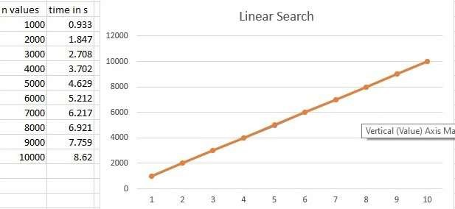

# Experiment 3

Sort a given set of N integer elements using Selection Sort technique and compute its time taken. Run the program for different values of N and record the time taken to sort.

Program:

#include <stdio.h>

#include<time.h> #define MAX 20000 void delay()

{

int i,temp; for(i=0;i<1000000;i++) temp=32/33233; return;

}

int main()

{

int a[MAX], k, n, i, j, position, swap; printf("Enter number of elements:"); scanf("%d", &n);

for (i = 0; i < n; i++)

{ a[i]= rand(); }

clock_t start=clock(); for(i = 0; i < n - 1; i++)

{delay(); position=i;

for(j = i + 1; j < n; j++)

{

if(a[position] > a[j]) position=j;

}

if(position != i)

{

swap=a[i]; a[i]=a[position]; a[position]=swap;

}

}

clock_t end=clock(); printf("Sorted Array: "); for(i = 0; i < n; i++) printf("%d ", a[i]);

printf("\nExecution time: %f",(double)(end-start)/CLOCKS_PER_SEC); return 0;

}

Output:

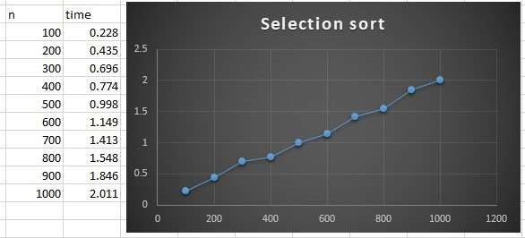

# Experiment 4

Write program to do the following:

1. Print all the nodes reachable from a given starting node in a digraph using BFS method.
2. Check whether a given graph is connected or not using DFS method.

a)

Program:

#include<stdio.h>

#include<stdlib.h>

#define MAX 100

#define initial 1

#define waiting 2

#define visited 3

int n;

int adj[MAX][MAX]; int state[MAX]; void create_graph(); void BF_Traversal(); void BFS(int v);

int queue[MAX], front = -1,rear = -1; void insert_queue(int vertex); int delete_queue(); int isEmpty_queue();

int main()

{

create_graph(); BF_Traversal(); return 0;

}

void BF_Traversal()

{ int v; for(v=0; v<n; v++) state[v] = initial; printf("Enter Start Vertex for BFS: \n"); scanf("%d", &v);

BFS(v);

}

void BFS(int v)

{ int i;

insert_queue(v); state[v] = waiting; while(!isEmpty_queue())

{

v = delete_queue( ); printf("%d ",v); state[v] = visited; for(i=0; i<n; i++)

{

if(adj[v][i] == 1 && state[i] == initial)

{

insert_queue(i); state[i] = waiting;

}

}

}

printf("\n");

}

void insert_queue(int vertex)

{

if(rear == MAX-1) printf("Queue Overflow\n"); else

{

if(front == -1) front = 0; rear = rear+1; queue[rear] = vertex ;

}

}

int isEmpty_queue()

{

if(front == -1 || front > rear)

return 1; else return 0;

}

int delete_queue()

{

int delete_item; if(front == -1 || front > rear)

{

printf("Queue Underflow\n"); exit(1);

}

delete_item = queue[front]; front = front+1; return delete_item;

}

void create_graph()

{

int count,max_edge,origin,destin;

printf("Enter number of vertices : "); scanf("%d",&n); max_edge = n*(n-1);

for(count=1; count<=max_edge; count++)

{

printf("Enter edge %d( -1 -1 to quit ) : ",count); scanf("%d %d",&origin,&destin);

if((origin == -1) && (destin == -1)) break;

if(origin>=n || destin>=n || origin<0 || destin<0)

{

printf("Invalid edge!\n"); count--;

}

else

{

adj[origin][destin] = 1;

} } }

Output:

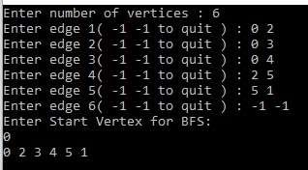

b)

Program:

#include<stdio.h> #include<stdlib.h> void DFS(int); int G[10][10],visited[10],n;

void DFS(int i)

{ int j;

printf("\n%d",i); visited[i]=1; for(j=0;j<n;j++)

{if(!visited[j]&&G[i][j]==1)

{DFS(j); }

} }

void main()

{ int i,j;

printf("Enter number of vertices:"); scanf("%d",&n);

printf("\nEnter adjecency matrix of the graph:"); for(i=0;i<n;i++) for(j=0;j<n;j++) scanf("%d",&G[i][j]); for(i=0;i<n;i++) visited[i]=0; DFS(0); }

Output: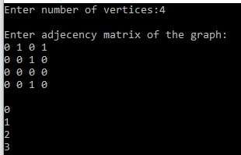

# Experiment 5

Sort a given set of N integer elements using Insertion Sort technique and compute its time taken.

Program:

#include <stdio.h>

#include<time.h> #define MAX 200000 void delay()

{

int i,j,temp; for(i=0;i<1000000;i++) temp=32/33233; return;

}

void insert(int a[], int n)

{

int i, j, temp; for (i = 1; i < n; i++) { temp = a[i]; j = i - 1;

while(j>=0 && temp <= a[j])

{ delay(); a[j+1] = a[j]; j = j-1;

}

a[j+1] = temp;

} }

void print(int a[], int n)

{ int i;

for (i = 0; i < n; i++) printf("%d ", a[i]);

}

int main() { clock_t start,end; int a[MAX],n,i;

printf("Enter the number of elements: "); scanf("%d",&n); for(i=0;i<n;i++)

{ a[i]= rand(); } start=clock(); insert(a, n); end=clock();

printf("\nAfter sorting array elements are - "); print(a, n);

printf("\nTime taken: %f", (double)(end-start)/CLOCKS_PER_SEC ); printf("\n"); return 0;

}

Output:

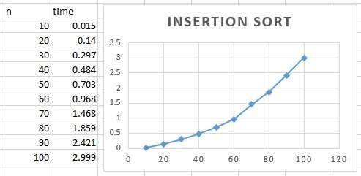

Experiment 6

Write a program to obtain the Topological ordering of vertices in a given digraph.

Program:

#include<stdio.h>

void topo(int,int);

int g[10][10],visited[10],deadend[10],d=-1,n; int sortedOrder[10],o,count=0;

int main()

{

printf("\n Enter the Number of Vertices : "); scanf("%d",&n); o=n;

printf("\n Enter the adjacency matrix:\n"); for(int i=0;i<n;i++) { for(int j=0;j<n;j++) scanf("%d",&g[i][j]); visited[i]=0;

}

printf("\n"); for(int i=0;i<n;i++)

{

topo(i,0);

}

printf("\n\n Topology Order: "); for(int i=0;i<n;i++)

{

printf(" %d ",sortedOrder[i]);

}

return 0;

}

void topo(int k,int flag)

{

if(flag==0 && visited[k]==0)

{

printf("\n %d ",k); sortedOrder[--o]=k;

}

else if(flag==0 && visited[k]!=0) printf(""); else

{

printf(" %d ",k); deadend[++d]=k;

}

visited[k]=1; for(int j=0;j<n;j++) if(visited[j]==0 && g[k][j]==1)

{ topo(j,1);

}

if(d>=0){

int temp=sortedOrder[o++]; for(int k=d;k>=0;k--,--d)

{

sortedOrder[--o]=deadend[k];

}

sortedOrder[--o]=temp;

}

}

Output:

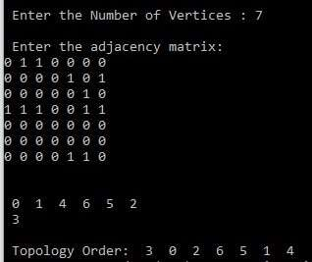

# Experiment 7

Implement Johnson Trotter algorithm to generate permutations.

Program:

#include <stdio.h> #include <stdlib.h> int flag = 0; int swap(int *a,int *b)

{

int t = *a; *a = *b;

*b = t;

}

int search(int arr[],int num,int mobile)

{ int g;

for(g=0;g<num;g++)

{

if(arr[g] == mobile)

{

return g+1;

} else

{ flag++;

}

}

return -1;

}

int find_Moblie(int arr[],int d[],int num)

{

int mobile = 0; int mobile_p = 0;

int i;

for(i=0;i<num;i++)

{

if((d[arr[i]-1] == 0) && i != 0)

{

if(arr[i]>arr[i-1] && arr[i]>mobile_p)

{

mobile = arr[i]; mobile_p = mobile;

} else { flag++ ; }

}

else if((d[arr[i]-1] == 1) & i != num-1)

{

if(arr[i]>arr[i+1] && arr[i]>mobile_p)

{

mobile = arr[i]; mobile_p = mobile;

} else { flag++;

} } else

{ flag++;

}

}

if((mobile_p == 0) && (mobile == 0)) return 0; else return mobile;

}

void permutations(int arr[],int d[],int num)

{ int i;

int mobile = find_Moblie(arr,d,num); int pos = search(arr,num,mobile); if(d[arr[pos-1]-1]==0) swap(&arr[pos-1],&arr[pos-2]); else

swap(&arr[pos-1],&arr[pos]); for(int i=0;i<num;i++)

{

if(arr[i] > mobile)

{

if(d[arr[i]-1]==0)

d[arr[i]-1] = 1; else d[arr[i]-1] = 0;

}

}

for(i=0;i<num;i++)

{

printf(" %d ",arr[i]);

}

}

int factorial(int k)

{ int f = 1; int i = 0; for(i=1;i<k+1;i++)

{ f = f*i;

}

return f;

}

int main()

{

int num = 0; int i,j,z=0; printf("Enter the number: "); scanf("%d",&num); int arr[num],d[num];

z = factorial(num); printf("\nPermutations: \n"); for(i=0;i<num;i++)

{ d[i] = 0; arr[i] = i+1; printf(" %d ",arr[i]);

}

printf("\n"); for(j=1;j<z;j++)

{

permutations(arr,d,num); printf("\n");

}

return 0;

}

Output:

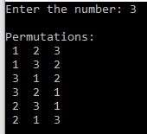

# Experiment 8

Sort a given set of N integer elements using Merge Sort technique and compute its time taken. Run the program for different values of N and record the time taken to sort.

Program:

#include<stdio.h>

#include<time.h>

void mergesort(int a[],int i,int j); void merge(int a[],int i1,int j1,int i2,int j2); void delay(); int main()

{ int n,i;

printf("Enter no of elements:"); scanf("%d",&n); int a[n]; for(i=0;i<n;i++) a[i] = rand();

clock_t start = clock(); mergesort(a,0,n-1); clock_t end = clock();

printf("\nSorted array is :"); for(i=0;i<n;i++) printf("%d ",a[i]); printf("\n\nThe total time taken is : %f",(double)(endstart)/CLOCKS_PER_SEC);

return 0;

}

void mergesort(int a[],int i,int j)

{

int mid;

if(i<j)

{

mid=(i+j)/2; mergesort(a,i,mid); mergesort(a,mid+1,j); merge(a,i,mid,mid+1,j);

}

}

void merge(int a[],int i1,int j1,int i2,int j2)

{

int temp[10000];

int i,j,k; i=i1; j=i2; k=0; while(i<=j1 && j<=j2)

{ delay(); if(a[i]<a[j]) temp[k++]=a[i++]; else

temp[k++]=a[j++];

}

while(i<=j1) temp[k++]=a[i++]; while(j<=j2) temp[k++]=a[j++];

for(i=i1,j=0;i<=j2;i++,j++) a[i]=temp[j];

}

void delay()

{ int i, k;

for(i=0;i<40000;i++) k= 33/333;

}

Output:

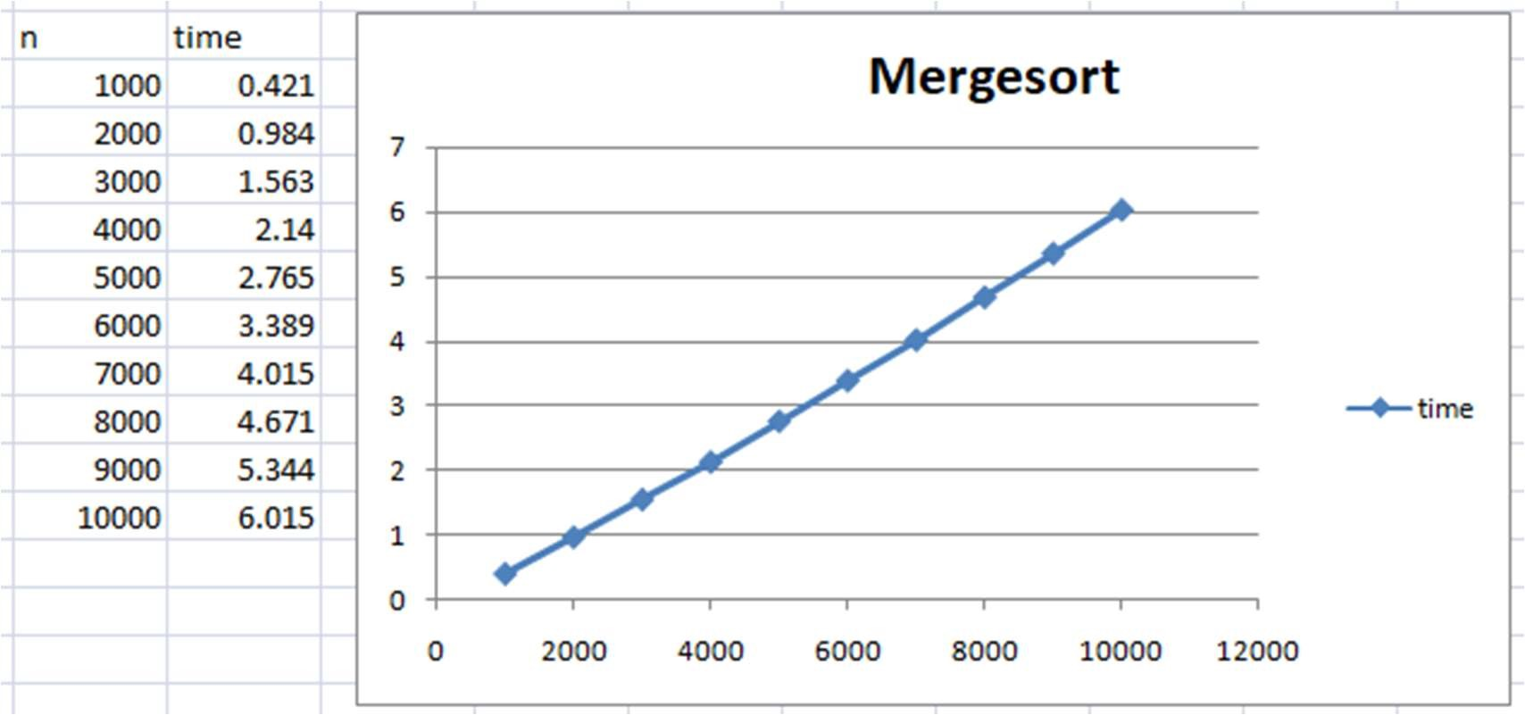

# Experiment 9

Sort a given set of N integer elements using Quick Sort technique and compute its time taken.

Program:

#include<stdio.h>

#include<time.h>

#define MAX 15000

void delay()

{

int i,temp; for(i=0;i<1000000;i++) temp=32/33233;

}

void quicksort(int number[MAX],int first,int last){ int i, j, pivot, temp; if(first<last){ pivot=first; i=first; j=last; while(i<j){ delay();

while(number[i]<=number[pivot]&&i<last) i++;

while(number[j]>number[pivot]) j--;

if(i<j){

temp=number[i]; number[i]=number[j]; number[j]=temp;

}

}

temp=number[pivot]; number[pivot]=number[j]; number[j]=temp; quicksort(number,first,j-1); quicksort(number,j+1,last);

}

}

int main(){ clock_t start,end; int i, count, a[MAX]; printf("No. of elements: "); scanf("%d",&count);

for(i=0;i<count;i++)

{

a[i]=rand();

}

start=clock(); quicksort(a,0,count-1); end=clock(); printf("Order of Sorted elements: "); for(i=0;i<count;i++) printf(" %d",a[i]);

printf("\nExecution time: %f",(double)(end-start)/CLOCKS_PER_SEC); return 0;

}

Output:

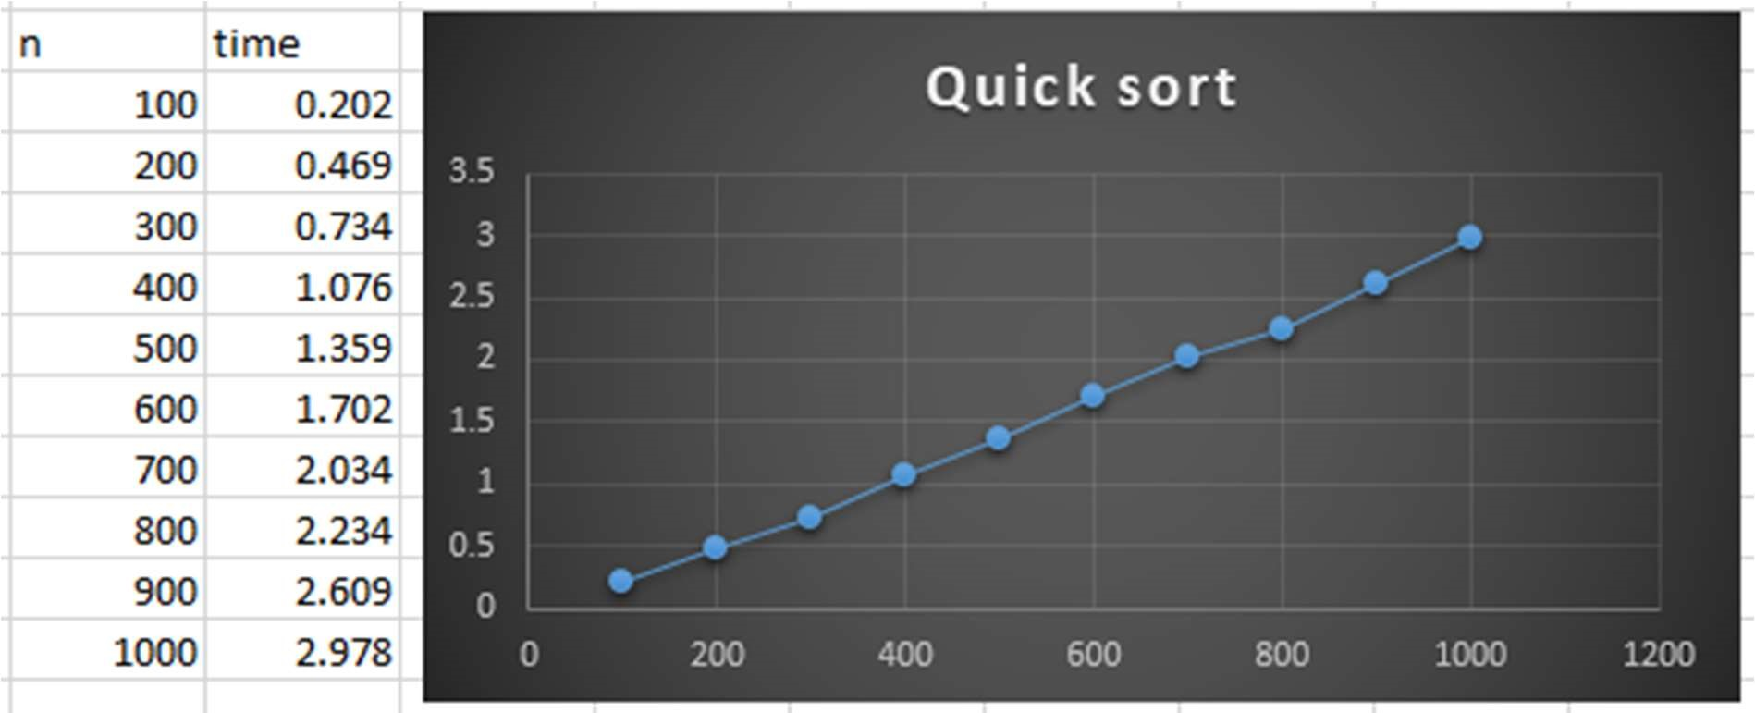

# Experiment 10

Sort a given set of N integer elements using Heap Sort technique and compute its time taken.

Program:

#include <stdio.h>

#include<time.h>

#define max 10000

void swap(int *a, int *b) { int temp = *a; *a = *b;

*b = temp;

}

void delay()

{ int i,j,temp; for(i=0;i<2000000;i++) temp=32/33233; }

void heapify(int arr[], int n, int i) { int largest = i; int left = 2 * i + 1; int right = 2 * i + 2;

if (left < n && arr[left] > arr[largest]) largest = left;

if (right < n && arr[right] > arr[largest])

largest = right; if (largest != i) { swap(&arr[i], &arr[largest]); heapify(arr, n, largest);

}

}

void heapSort(int arr[], int n) { for (int i = n / 2 - 1; i >= 0; i--) heapify(arr, n, i); for (int i = n - 1; i >= 0; i--) { swap(&arr[0], &arr[i]); delay(); heapify(arr, i, 0);

}

}

void printArray(int arr[], int n)

{

for (int i = 0; i < n; i++) printf("%d ", arr[i]); printf("\n");

}

int main()

{

int arr[max],m,i; clock_t start,end; printf("Enter the number of elements: "); scanf("%d",&m); for(i=0;i<m;i++)

{

arr[i]=rand();

}

start=clock(); heapSort(arr, m); end=clock();

printf("\n\nSorted array is given in the following way \n"); printArray(arr, m);

printf("\nExecution time: %f",(double)(end-start)/CLOCKS_PER_SEC);

}

Output:

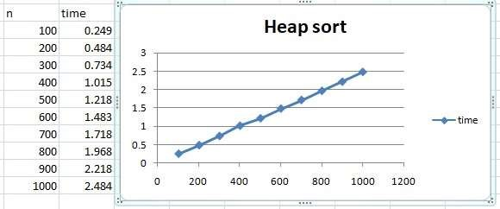

# Experiment 11

Implement Warshall’s algorithm using dynamic programming.

Program:

#include<stdio.h>

#include<conio.h>

#include<math.h>

int max(int,int);

void warshal(int p[10][10],int n) { int i,j,k; for (k=1;k<=n;k++) for (i=1;i<=n;i++) for (j=1;j<=n;j++)

p[i][j]=max(p[i][j],p[i][k]&&p[k][j]);

}

int max(int a,int b) { if(a>b)

return(a); else return(b);

}

void main() {

int p[10][10]= {0},n,e,u,v,i,j; printf("\n Enter the number of vertices:"); scanf("%d",&n);

printf("\n Enter the number of edges:");

scanf("%d",&e); for (i=1;i<=e;i++) {

printf("\n Enter the end vertices of edge %d:",i); scanf("%d%d",&u,&v); p[u][v]=1;

}

printf("\n Matrix of input data: \n"); for (i=1;i<=n;i++) { for (j=1;j<=n;j++) printf("%d\t",p[i][j]); printf("\n");

}

warshal(p,n);

printf("\n Transitive closure: \n"); for (i=1;i<=n;i++) { for (j=1;j<=n;j++) printf("%d\t",p[i][j]); printf("\n");

}

getch();

}

Output:

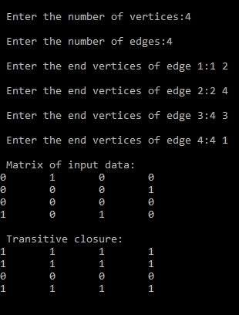

# Experiment 12

Implement 0/1 Knapsack problem using dynamic programming.

Program:

#include<stdio.h>

#include<conio.h>

int w[10],p[10],v[10][10],n,i,j,cap,x[10]= {0};

int max(int i,int j) {

return ((i>j)?i:j);

}

int knap(int i,int j) {

int value;

if(v[i][j]<0) {

if(j<w[i])

value=knap(i-1,j); else

value=max(knap(i-1,j),p[i]+knap(i-1,j-w[i])); v[i][j]=value;

}

return(v[i][j]);

}

void main() {

int profit,count=0;

printf("\nEnter the number of elements\n"); scanf("%d",&n);

printf("Enter the profit and weights of the elements\n"); for (i=1;i<=n;i++) { printf("For item no %d\n",i); scanf("%d%d",&p[i],&w[i]);

}

printf("\nEnter the capacity \n"); scanf("%d",&cap); for (i=0;i<=n;i++) for (j=0;j<=cap;j++) if((i==0)||(j==0)) v[i][j]=0; else v[i][j]=-1; profit=knap(n,cap);

i=n; j=cap;

while(j!=0&&i!=0) { if(v[i][j]!=v[i-1][j]) {

x[i]=1; j=j-w[i]; i--;

} else i--;

}

printf("Items included are\n"); printf("Sl.no\tweight\tprofit\n"); for (i=1;i<=n;i++) if(x[i])

printf("%d\t%d\t%d\n",++count,w[i],p[i]); printf("Count:%d",count); printf("\nTotal profit = %d\n",profit);

getch();

}

Output:

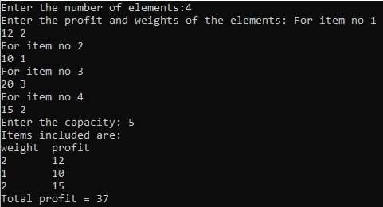

# Experiment 13

Implement All Pair Shortest paths problem using Floyd’s algorithm.

Program:

#include<stdio.h> #include<conio.h> int min(int,int);

void floyds(int p[10][10],int n) { int i,j,k; for (k=1;k<=n;k++) for (i=1;i<=n;i++) for (j=1;j<=n;j++) if(i==j) p[i][j]=0; else

p[i][j]=min(p[i][j],p[i][k]+p[k][j]);

}

int min(int a,int b) { if(a<b)

return(a); else return(b);

}

void main() {

int p[10][10],w,n,e,u,v,i,j;

printf("\n Enter the number of vertices:");

scanf("%d",&n);

printf("\n Enter the number of edges:\n"); scanf("%d",&e); for (i=1;i<=n;i++) { for (j=1;j<=n;j++) p[i][j]=999;

}

for (i=1;i<=e;i++) {

printf("\n Enter the end vertices of edge%d with its weight \n",i);

scanf("%d%d%d",&u,&v,&w); p[u][v]=w;

}

printf("\n Matrix of input data:\n"); for (i=1;i<=n;i++) { for (j=1;j<=n;j++) printf("%d \t",p[i][j]); printf("\n");

}

floyds(p,n);

printf("\n Distance matrix:\n"); for (i=1;i<=n;i++) { for (j=1;j<=n;j++) printf("%d \t",p[i][j]); printf("\n");

}

printf("\n The shortest paths are:\n"); for (i=1;i<=n;i++) for (j=1;j<=n;j++) {

if(i!=j)

printf("\n <%d,%d>=%d",i,j,p[i][j]);

}

getch();

}

Output:

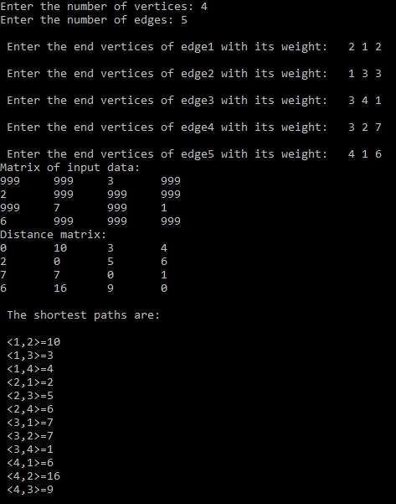

# Experiment 14

Find Minimum Cost Spanning Tree of a given undirected graph using Prim’s algorithm.

Program:

#include<stdio.h>

int main()

{

int cost[10][10],visited[10]={0},i,j,n,no_e=1,min,a,b,min_cost=0; printf("Enter number of nodes "); scanf("%d",&n);

printf("Enter cost in form of adjacency matrix\n"); for(i=1;i<=n;i++)

{

for(j=1;j<=n;j++)

{

scanf("%d",&cost[i][j]); if(cost[i][j]==0) cost[i][j]=1000;

}

}

visited[1]=1; // visited first node while(no_e<n)

{

min=1000; for(i=1;i<=n;i++) {

for(j=1;j<=n;j++)

{

if(cost[i][j]<min)

{ if(visited[i]!=0)

{ min=cost[i][j]; a=i; b=j;

}

}

}

}

if(visited[b]==0)

{

printf("\n%d to %d cost=%d",a,b,min); min_cost=min_cost+min; no_e++;

}

visited[b]=1; cost[a][b]=cost[b][a]=1000;

}

printf("\nminimum weight is %d",min_cost); return 0;

}

Output:

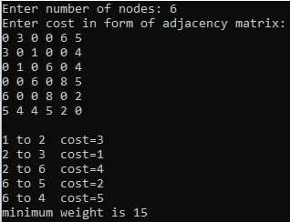

# Experiment 15

Find Minimum Cost Spanning Tree of a given undirected graph using Kruskal’s algorithm.

Program:

#include <stdio.h>

#include <conio.h>

#include <stdlib.h>

int i, j, k, a, b, u, v, n, ne = 1;

int min, mincost = 0, cost[9][9], parent[9];

int find(int); int uni(int, int);

void main()

{

printf("Enter the no. of vertices:\n"); scanf("%d", &n);

printf("\nEnter the cost adjacency matrix:\n"); for (i = 1; i <= n; i++)

{

for (j = 1; j <= n; j++)

{

scanf("%d", &cost[i][j]); if (cost[i][j] == 0) cost[i][j] = 999;

}

}

printf("The edges of Minimum Cost Spanning Tree are\n"); while (ne < n)

{

for (i = 1, min = 999; i <= n; i++)

{

for (j = 1; j <= n; j++)

{

if (cost[i][j] < min)

{

min = cost[i][j]; a = u = i; b = v = j;

}

}

}

u = find(u); v = find(v);

if (uni(u, v))

{

printf("%d edge (%d,%d) =%d\n", ne++, a, b, min); mincost += min;

}

cost[a][b] = cost[b][a] = 999;

}

printf("\nMinimum cost = %d\n", mincost); getch();

}

int find(int i)

{

while (parent[i]) i = parent[i]; return i;

}

int uni(int i, int j)

{ if (i != j)

{

parent[j] = i; return 1;

}

return 0;

}

Output:

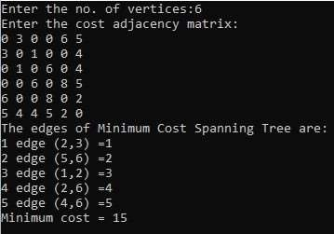

# Experiment 16

From a given vertex in a weighted connected graph, find shortest paths to other vertices using Dijkstra’s algorithm

Program:

#include<stdio.h>

#include<conio.h>

#define INFINITY 9999 #define MAX 10

void dijkstra(int G[MAX][MAX], int n, int startnode);

void main(){

int G[MAX][MAX], i, j, n, u; printf("\nEnter the no. of vertices: "); scanf("%d", &n);

printf("\nEnter the adjacency matrix:\n"); for(i=0;i < n;i++) for(j=0;j < n;j++) scanf("%d", &G[i][j]);

printf("\nEnter the starting node: "); scanf("%d", &u); dijkstra(G,n,u); getch();

}

void dijkstra(int G[MAX][MAX], int n, int startnode)

{

int cost[MAX][MAX], distance[MAX], pred[MAX];

int visited[MAX], count, mindistance, nextnode, i,j; for(i=0;i < n;i++) for(j=0;j < n;j++)

if(G[i][j]==0) cost[i][j]=INFINITY;

else

cost[i][j]=G[i][j];

for(i=0;i< n;i++)

{

distance[i]=cost[startnode][i]; pred[i]=startnode; visited[i]=0;

}

distance[startnode]=0; visited[startnode]=1; count=1;

while(count < n-1){ mindistance=INFINITY; for(i=0;i < n;i++)

if(distance[i] < mindistance&&!visited[i])

{

mindistance=distance[i];

nextnode=i;

}

visited[nextnode]=1; for(i=0;i < n;i++) if(!visited[i]) if(mindistance+cost[nextnode][i] < distance[i])

{

distance[i]=mindistance+cost[nextnode][i];

pred[i]=nextnode;

}

count++;

}

for(i=0;i < n;i++)

if(i!=startnode)

{

printf("\n\nDistance of %d = %d", i, distance[i]); printf("\nPath = %d ", i);

j=i;

int countn=1;

do

{

j=pred[j];

printf("<-%d", j); countn++;

}

while(j!=startnode);

printf("\nCount=%d",countn);

}

}

Output:

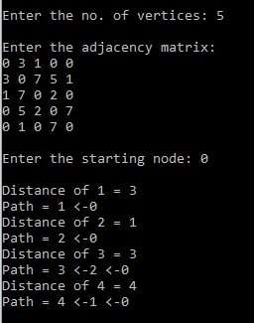

# Experiment 17

Implement “Sum of Subsets” using Backtracking. Problem: Find a subset of a given set S = {s1,s2,……,sn} of n positive integers whose sum is equal to a given positive integer d. For example, if S = {1,2,5,6,8} and d = 9 there are two solutions {1,2,6} and {1,8}. A suitable message is to be displayed if the given problem instance doesn’t have a solution.

Program:

#include<stdio.h>

#include<conio.h>

#define TRUE 1 #define FALSE 0 int inc[50],w[50],sum,n; int promising(int i,int wt,int total) {

return(((wt+total)>=sum)&&((wt==sum)||(wt+w[i+1]<=sum)));

}

void main() { int i,j,n,temp,total=0; printf("Enter how many numbers:\n"); scanf("%d",&n);

printf("Enter %d numbers to th set:\n",n); for (i=0;i<n;i++) {

scanf("%d",&w[i]); total+=w[i];

}

printf("Input the sum value to create sub set: "); scanf("%d",&sum);

for (i=0;i<=n;i++) for (j=0;j<n-1;j++) if(w[j]>w[j+1]) { temp=w[j]; w[j]=w[j+1]; w[j+1]=temp;

}

printf("The given %d numbers in ascending order:\n",n); for (i=0;i<n;i++) printf("%d ",w[i]); if((total<sum))

printf("\n Subset construction is not possible"); else {

for (i=0;i<n;i++) inc[i]=0; printf("\nSolution:\n"); sumset(-1,0,total);

}

getch();

}

void sumset(int i,int wt,int total) {

int j;

if(promising(i,wt,total)) {

if(wt==sum) { printf("{"); for (j=0;j<=i;j++) if(inc[j]) printf("%d ",w[j]); printf("}\n");

} else { inc[i+1]=TRUE;

sumset(i+1,wt+w[i+1],total-w[i+1]); inc[i+1]=FALSE;

sumset(i+1,wt,total-w[i+1]);

}

}

}

Output:

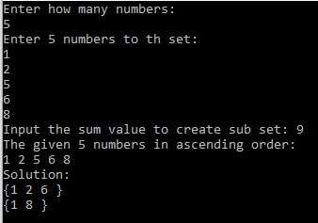

# Experiment 18

Implement “N-Queens Problem” using Backtracking.

Program:

#include<stdio.h> #include<math.h> int board[20],count;

int main()

{ int n,i,j;

void queen(int row,int n); printf("Enter number of Queens:"); scanf("%d",&n); queen(1,n); return 0;

}

void print(int n)

{ int i,j;

printf("\n\nSolution %d:\n\n",++count); for(i=1;i<=n;++i) printf("\t%d",i); for(i=1;i<=n;++i)

{

printf("\n\n%d",i); for(j=1;j<=n;++j)

{

if(board[i]==j) printf("\tQ"); else printf("\t-");

}

}

}

int place(int row,int column)

{ int i;

for(i=1;i<=row-1;++i)

{

if(board[i]==column) return 0; else

if(abs(board[i]-column)==abs(i-row)) return 0;

}

return 1;

}

void queen(int row,int n)

{

int column; for(column=1;column<=n;++column)

{

if(place(row,column))

{

board[row]=column; if(row==n) print(n); else

queen(row+1,n);

}

}

}

Output:

